BIRLA INSTITUTE OF TECHNOLOGY AND SCIENCE, PILANI
CE F211 MECHANICS OF SOLIDS 1st SEMESTER 2023-24
ASSIGNMENT #3 (CHAP 3- Forces and Moments transmitted by slender members)

[NOTE: Contraflexure point : It is the point in a bending moment diagram, at which the bending moment curve intersects with the zero line.]

- The simple beam AB shown in the figure supports a concentrated load and a segment of uniform load. Draw the shear-force and bending-moment diagrams for this beam. Find the position and magnitude of the maximum bending moment. [k is kilopound also expressed as kips. 1 kips = 1000 lbs] [ANS: R_{A} = 1.25 k; R_{B} = 13.75 k; M_{bmax}(13.125) = 47.26 k-ft]
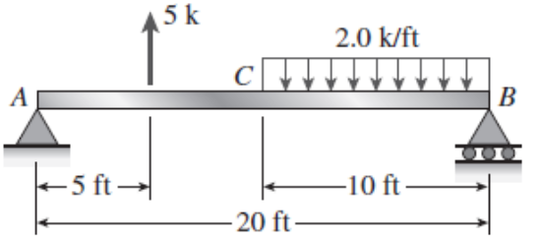
- A beam ABC is simply supported at A and B and has an overhang BC (see figure). The beam is loaded by two forces P and a clockwise couple of moment Pa that act through the arrangement shown. Draw the shear-force and bending-moment diagrams for beam ABC. [ANS: R_{A} = 0; R_{B} = 2P]
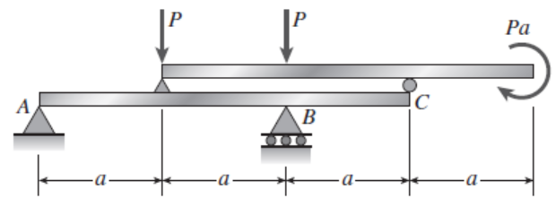
- A simple beam AB is loaded by two segments of uniform load and two horizontal forces acting at the ends of a vertical arm (see figure). Draw the shear-force and bending-moment diagrams for this beam. Also determine the point on the beam where the shear force is zero.[ANS: R_{A} = 6 kN; R_{B} = 10 kN; V(1.5) = 0]
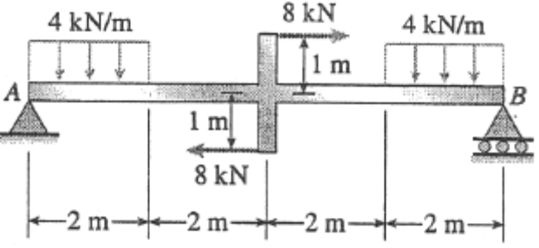

4. Draw the Bending Moment & Shear Force Diagrams of the following figures (a) to (d).
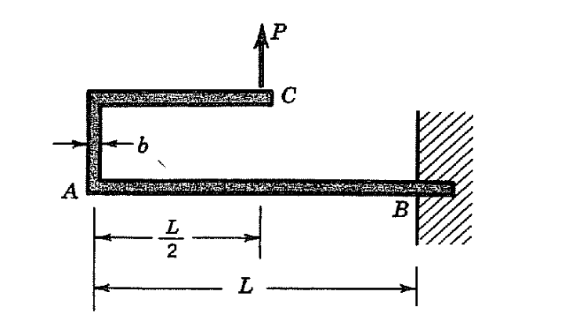

(a)

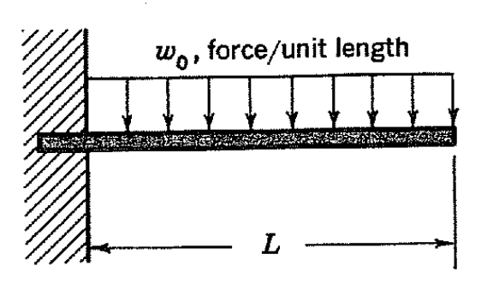
(b)

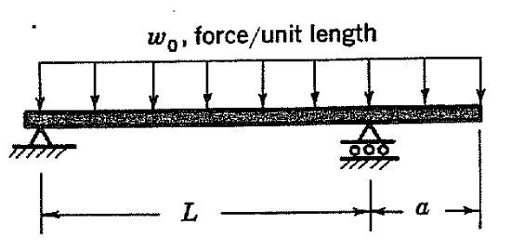
(c)

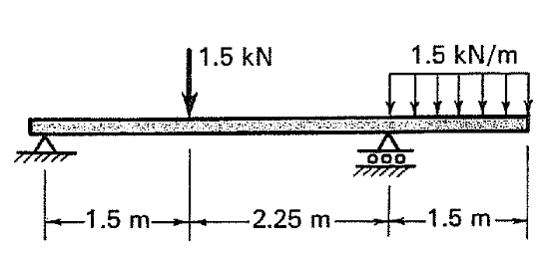
(d)

